**How to Fix “Task Manager has been Disabled by your Administrator” Problem in Windows?**

That's a very common problem for Windows users. Many times when you try to open Task Manager, you find that "Task Manager" option has been grayed out:

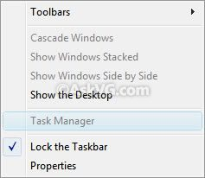

Also when you try to run it by typing "**taskmgr**" in RUN dialog box, Windows shows following error message:

Task Manager has been disabled by your administrator.

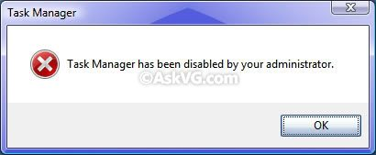

There might be 2 possible reasons behind this problem:

* Your system administrator applied the restriction using Registry Editor or Group Policy Editor.
* Your system has been infected with virus and it has disabled the Task Manager.

If you are already the Administrator of the system, then your system is most probably infected. You should follow the instructions given in following topic first:

**[Is Your System Infected with a Virus / Spyware / Adware / Trojan?](http://www.askvg.com/is-your-system-infected-with-a-virus-spyware-adware-trojan/" \o "Go to Is Your System Infected with a Virus / Spyware / Adware / Trojan?)**

Now if your system in not infected or you have successfully removed the virus, then you can follow these simple steps to enable Task Manager again:

**1.** Type **regedit** in RUN dialog box or Start Menu Search box and press Enter. It'll open Registry Editor. If Registry editor is also disabled, then follow instructions given in following tutorial:

**[How to Enable Tools -> Folder Options and Registry Editor in Windows](http://www.askvg.com/how-to-enable-tools-folder-options-and-registry-editor-in-windows/" \o "Go to How to Enable Tools -> Folder Options and Registry Editor in Windows)**

**2.** Now go to following keys one by one:

HKEY_CURRENT_USER\Software\Microsoft\Windows\CurrentVersion\Policies\System  
HKEY_LOCAL_MACHINE\Software\Microsoft\Windows\CurrentVersion\Policies\System  
HKEY_USERS\.default\Software\Microsoft\Windows\CurrentVersion\Policies\System

and look for a DWORD value "**DisableTaskMgr**" in right-side pane. If you find it, delete it.

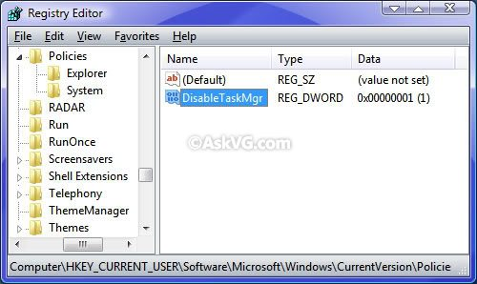

**3.** That's it. Now Task Manager will be enabled.

**PS:** If you are not familiar with editing the registry, then you can use ready-made registry script to do the task automatically. Download following ZIP file, extract it and then run the extracted .REG file. It'll ask for confirmation, accept it: